6.27: a) The friction force is 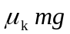, which is directed against the car’s motion, so the net work done is 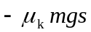. The change in kinetic energy is 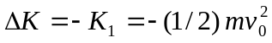, and so 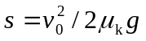. b) From the result of part (a), the stopping distance is proportional to the square of the initial speed, and so for an initial speed of 60 km/h, 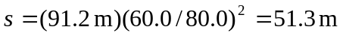. (This method avoids the intermediate calculation of 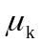, which in this case is about 0.279.)

